**Adobe forms demo program # 3.**

***Program theme:*** *In this demo program you will get how to call Adobe form from the Driver Program/ Print Program and the basic navigation how to create the Adobe Interface and Adobe Form.*

**Step # 1:** Go to transaction code SFP (For Adobe form and Interface creation).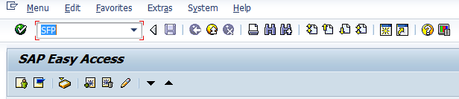

**Step # 2:** Select the interface radio button Provide the Interface name (Start with ‘Z’ or ‘Y’) and click on create.

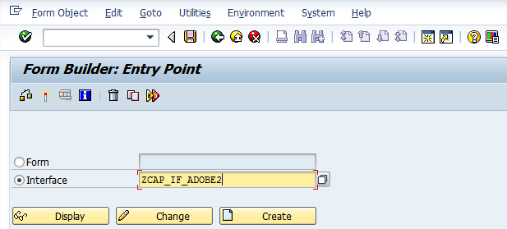

**Step # 3:** Provide the Interface description and select the Interface type as ABAP Dictionary-Based Interface from the drop down option and Click on the Save.

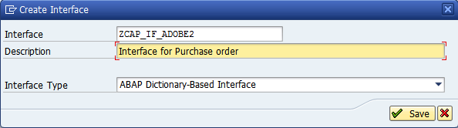

**Step # 4:** Save it in the package.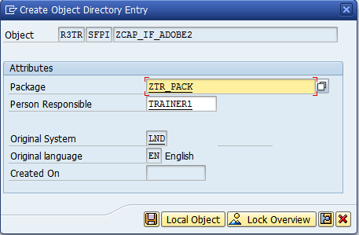

**Step # 5:** Select the Import parameter under the Form Interface.

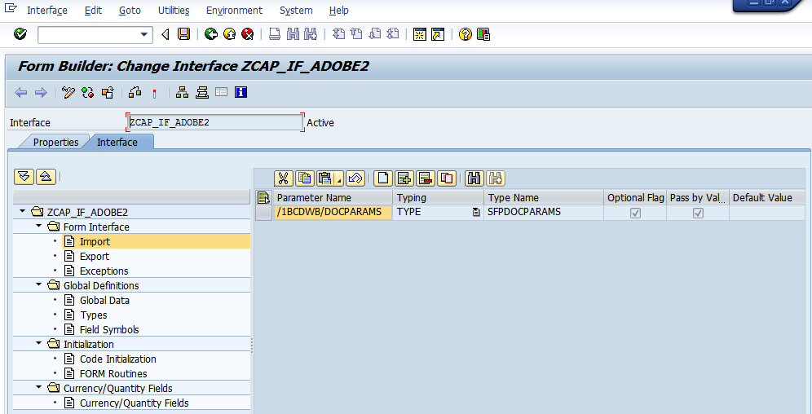

**Step # 6:** Click on Create button (5th Icon) in the tool bar of the right side window.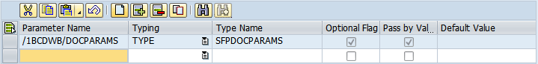

**Step # 7:** Provide the parameter names as EBELN, EBELP, MATNR, BUKRS and WERKS select the TYPE under the Typing attribute and provide the data element names (EBELN, EBELP, MATNR, BUKRS and EWERK) under the Type Name.

**Save and activate the Interface.**

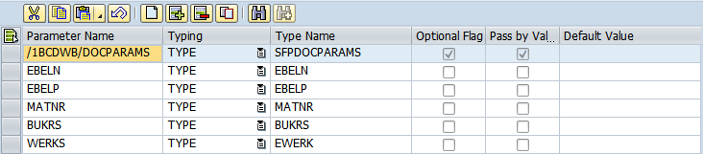

**Step # 8:** Go to transaction code SFP (For Adobe form and Interface creation). Select the Form Radio button and provide the Form Name (Start with ‘Z’ or ‘Y’) and click on create.

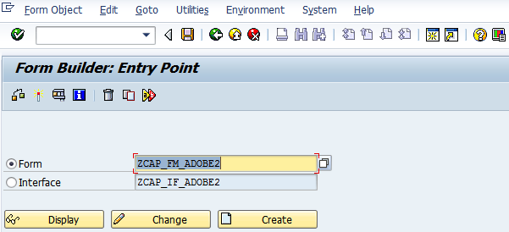

**Step # 9:** Provide the Adobe form description and click on Save.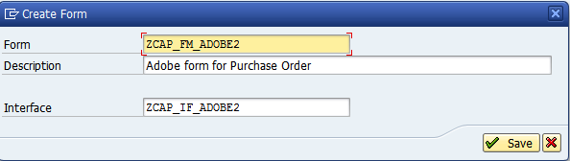

**Step # 10:** Save it in the package.

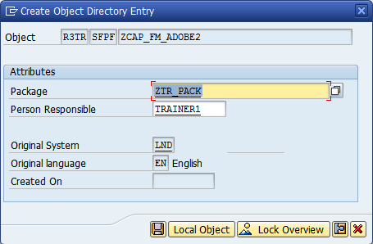

**Step # 11:** Expand the Import parameter under the interface and drag and drop all the Interface Fields to the context folder.

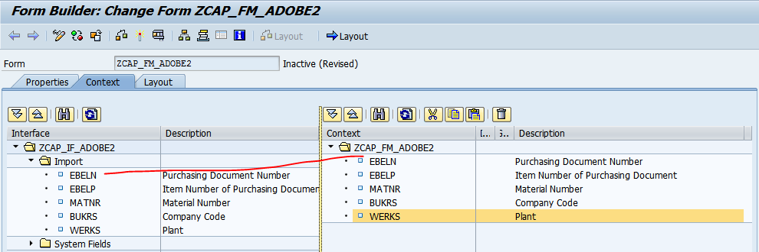

**Step # 12:** Double click on the EBELN to set more properties and conditions and repeat the same for other fields to set the properties.

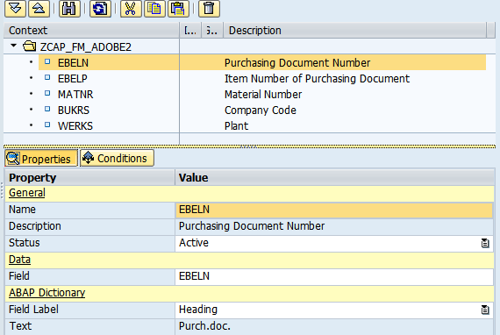

**Step # 13:** Click on the Layout tab.

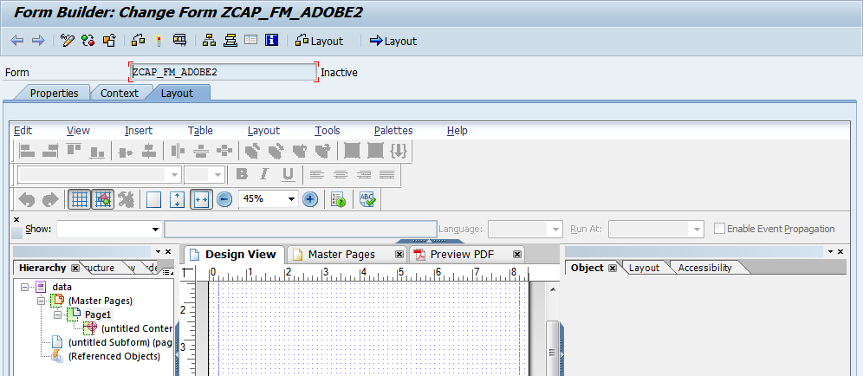

**Step # 13:** Navigate from **Hierarchy View** to **Data View** Drag all the fields to the Layout and design accordingly. **Note:** Binding will take place automatically for all the fields not required to do manually.

Save and activate the form.

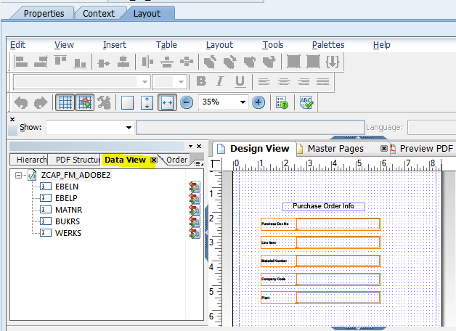

**Step # 14:** Go to SE38 Transaction Code (Executable Program) and Create the Adobe form Driver Program/ Print Program.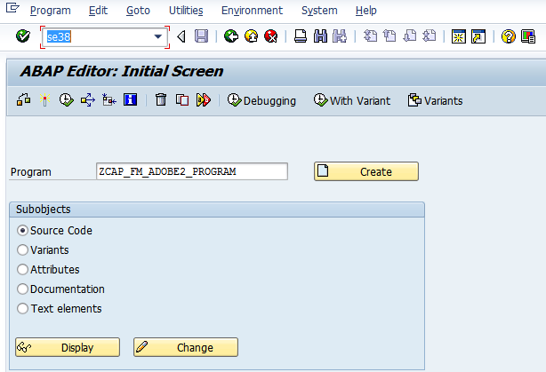

**Step # 15:** Provide the title and select the executable program and click on save.

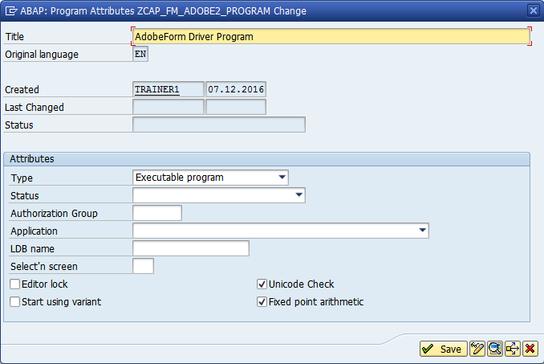

**Step # 16:** Save it in the package.

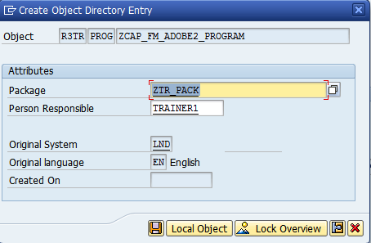

**Step # 17:** Write the code logic.

Step #17.1 Create include program.

*&---------------------------------------------------------------------*  
*&  Include           ZCAP_FM_ADOBE2_PROGRAM_INCL  
*&---------------------------------------------------------------------*  
  
TABLES : ekpo.  
  
TYPES: ty_outputparams type sfpoutputparams,  
       ty_docparams type sfpdocparams.  
  
data wa_outputparams type sfpoutputparams.  
  
data wa_docparams type sfpdocparams.  
  
DATA gv_fm_name type rs38l_fnam.  
  
DATA : gv_ebeln TYPE ebeln,  
       gv_ebelp TYPE ebelp,  
       gv_matnr TYPE matnr,  
       gv_werks TYPE ewerk,  
       gv_bukrs TYPE bukrs.

Step # 17. 2 Create executable program.

*&---------------------------------------------------------------------*  
*& Report ZCAP_FM_ADOBE2_PROGRAM  
*&---------------------------------------------------------------------*  
*&  
*&---------------------------------------------------------------------*  
REPORT ZCAP_FM_ADOBE2_PROGRAM.  
  
INCLUDE  ZCAP_FM_ADOBE2_PROGRAM_INCL.  
  
PARAMETERS: p_ebeln type ebeln.  
  
START-OF-SELECTION.  
  
wa_outputparams-DEVICE = 'PRINTER'.  
wa_outputparams-DEST  = 'LP01'.  
wa_outputparams-NODIALOG = 'X'.  
wa_outputparams-PREVIEW  = 'X'.  
  
CALL FUNCTION 'FP_JOB_OPEN'  
  CHANGING  
    IE_OUTPUTPARAMS       = wa_outputparams  
* EXCEPTIONS  
*   CANCEL                = 1  
*   USAGE_ERROR           = 2  
*   SYSTEM_ERROR          = 3  
*   INTERNAL_ERROR        = 4  
*   OTHERS                = 5  
          .  
IF SY-SUBRC <> 0.  
* Implement suitable error handling here  
ENDIF.  
  
CALL FUNCTION 'FP_FUNCTION_MODULE_NAME'  
  EXPORTING  
   I_NAME                     = 'ZCAP_FM_ADOBE2'    " Adobe form name.  
 IMPORTING  
   E_FUNCNAME                 = gv_fm_name  
*   E_INTERFACE_TYPE           =  
*   EV_FUNCNAME_INBOUND        =  
          .  
wa_docparams-langu = 'E'.  
wa_docparams-country = 'IN'.  
  
SELECT SINGLE EBELN  
       EBELP  
       MATNR  
       WERKS  
       BUKRS FROM EKPO  
       INTO (GV_EBELN, GV_EBELP, GV_MATNR, GV_BUKRS, GV_WERKS)  
      WHERE EBELN EQ P_EBELN.  
  
CALL FUNCTION gv_fm_name    " Call Adobe form generated function module  
  EXPORTING  
   /1BCDWB/DOCPARAMS        = wa_docparams  
    EBELN                    = gv_ebeln  
    EBELP                    = gv_ebelp  
    MATNR                    = gv_matnr  
    BUKRS                    = gv_bukrs  
    WERKS                    = gv_werks  
* IMPORTING  
*   /1BCDWB/FORMOUTPUT       =  
* EXCEPTIONS  
*   USAGE_ERROR              = 1  
*   SYSTEM_ERROR             = 2  
*   INTERNAL_ERROR           = 3  
*   OTHERS                   = 4  
          .  
IF SY-SUBRC <> 0.  
* Implement suitable error handling here  
ENDIF.  
CALL FUNCTION 'FP_JOB_CLOSE'  
* IMPORTING  
*   E_RESULT             =  
* EXCEPTIONS  
*   USAGE_ERROR          = 1  
*   SYSTEM_ERROR         = 2  
*   INTERNAL_ERROR       = 3  
*   OTHERS               = 4  
          .  
IF SY-SUBRC <> 0.  
* Implement suitable error handling here  
ENDIF.

**Step # 18:** Save and activate the program and execute (F8).

Provide the purchase order no and execute.

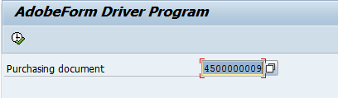

**Step # 19:** Provide the Output Device as LP01 (Default Print Purview) and click on Print Preview.

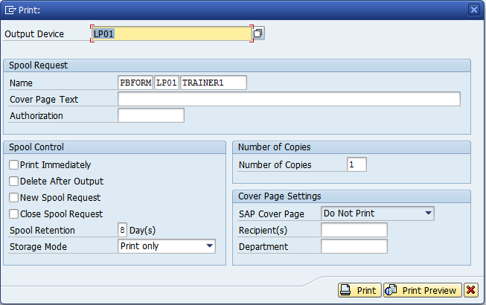

**Step # 20:** Check the below output through the print program.

